**Module -18 Assignment**

**Q1.) What are conditional statements? Explain conditional statements with syntax and examples.**

Conditional statements in JavaScript are used to perform different actions based on different conditions. These conditions are evaluated as either **true** or **false**, and based on that, specific blocks of code are executed.

**Types of Conditional Statements in JavaScript:-**

1. **if statement**

The if statement executes a block of code only if a specified condition is true.

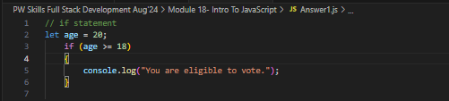

1. **if...else statement**

The if...else statement allows you to execute one block of code if the condition is true, and another block if the condition is false.

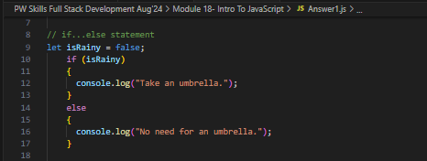

1. **if...else if...else statement**

This statement allows you to test multiple conditions and execute different blocks of code based on which condition is true.

1. **switch statement**

**The switch statement is used to execute one block of code out of many based on the value of an expression.**

**Q2.) Write a program that grades students based on their marks**

* **If greater than 90 then A Grad**
* **If between 70 and 90 then a B grad**
* **If between 50 and 70 then a C grad**
* **Below 50 then an F grade**

**Q3.) What are loops, and what do we need them? Explain different types of loops with their syntax and examples.**

Loops in JavaScript (and programming in general) are used to repeatedly execute a block of code as long as a certain condition is met. Loops help to automate repetitive tasks, which would otherwise require writing the same code multiple times. By using loops, you can iterate over collections of data, perform repetitive actions, and save time.

**Why Do We Need Loops?**

* **Reduce Repetition**: Loops allow you to avoid writing the same code over and over again.
* **Work with Collections**: Loops are useful for iterating through arrays, lists, or other collections.
* **Dynamic Code Execution**: Loops make it easy to perform a task a certain number of times or until a certain condition is met.

**Types of Loops in JavaScript:-**

1. **for loop**

The for loop is used when you know how many times you want to loop beforehand. It consists of three parts: initialization, condition, and increment/decrement.

1. **while loop**

The while loop continues executing the code block as long as the specified condition remains true.

1. **do...while loop**

The do...while loop is similar to the while loop, but the condition is checked **after** the code block has been executed. This guarantees that the loop runs at least once.

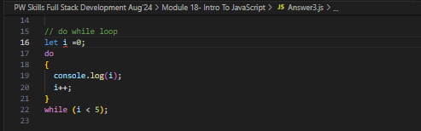

Output of for loop:-

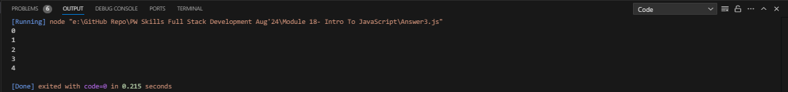

Output of While loop: -



Output of Do While loop:-



**Q4.) Generate numbers between any 2 given numbers.**

**Ex:**

* **const num1 = 10**
* **const num2 = 25;**

**Output: 11, 12, 13, …., 25**

**Q5.) Use the while loop to print numbers from 1 to 25 in ascending and descending order.**

